Legacy TA/PIA Code. Compatibility list:

See manual for code modification details.

To run this code you will require:

A Laser and/ or LED/powder supply.

A NI DAQ Card (NI DAQ 6211 6361 will run without code modification)

An oscilloscope (Techronix DPO 3012 will run without code modification – you can get them on ebay these days)

BNC cables

A PIN diode and a fast response high gain preamplifier – somewhere around 105 would be a good gain.

A monochromator – we use newport oriel cornerstone 130 – the new models will require code modification. The PTI monochromators that are also compatible with the code have been long disused.

A stabilised high intensity light source (80 Watt W halogen will work).

Planoconvex lenses to collimate, focus, re-collimate and re-focus – mount these on an optical rail.

A shutter/chopper. Any stepper motor compatible with USB should be fine.

Note: in PIA mode the DAQ will send a trigger pulse from one of the variable inputs/outputs which can be captured to trigger both the DAQ and scope.

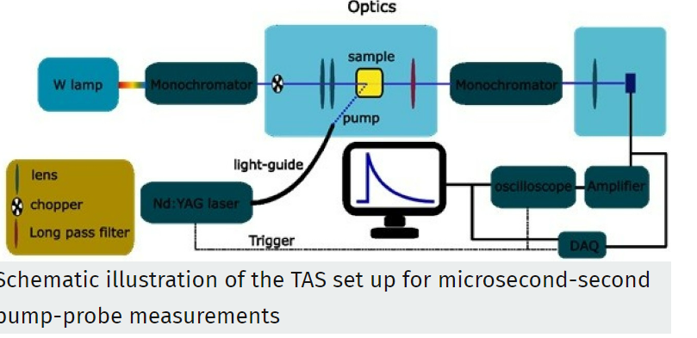Credit: Camilo Mesa.